Name:Roshini B T
Reg No:192524064
Course Code:ITA0613
EXPERIMENT NO: 1
FIND-S ALGORITHM
Aim
To implement and demonstrate the FIND-S algorithm for finding the most specific hypothesis that is consistent with a given set of positive training examples.
Procedure
- Collect a training dataset containing attributes and their corresponding target class labels.
- Initialize the hypothesis with the most specific values.
- Read each training example one by one.
- If the training example is positive (Yes):
  - Compare it with the current hypothesis.
  - If an attribute value differs, replace that attribute in the hypothesis with '?' (any value).
- Ignore all negative (No) training examples.
- Continue the process until all training examples are examined.
- Display the final hypothesis obtained.
- Verify that the final hypothesis correctly represents the most specific concept consistent with all positive examples.
INPUT:
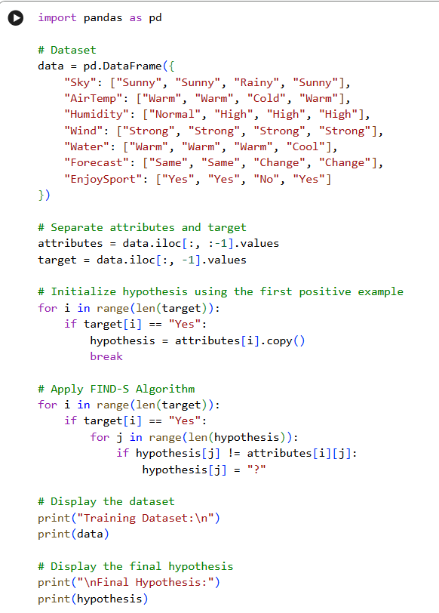

OUTPUT:
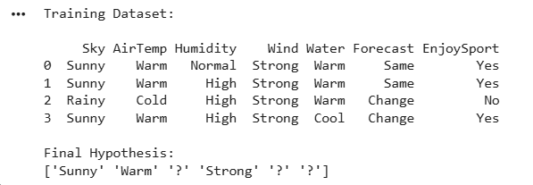

EXPERIMENT NO: 2
CANDIDATE-ELIMINATION ALGORITHM
Aim
To implement the Candidate-Elimination algorithm in Python to determine the version space by identifying all hypotheses that are consistent with the given training data stored in a CSV file.
Procedure
- Import the required Python libraries.
- Load the training dataset from a CSV file.
- Separate the attributes and target class labels from the dataset.
- Initialize the Specific Hypothesis (S) with the first positive training example.
- Initialize the General Hypothesis (G) with the most general hypothesis.
- Process each training example one by one.
- For each positive example, generalize the Specific Hypothesis (S) and remove inconsistent hypotheses from the General Hypothesis (G).
- For each negative example, specialize the General Hypothesis (G) by removing hypotheses that incorrectly classify the negative example while keeping them consistent with the Specific Hypothesis (S).
- Continue updating S and G until all training examples have been processed.
- Display the final Specific Hypothesis, General Hypothesis, and the Version Space containing all hypotheses consistent with the training data.
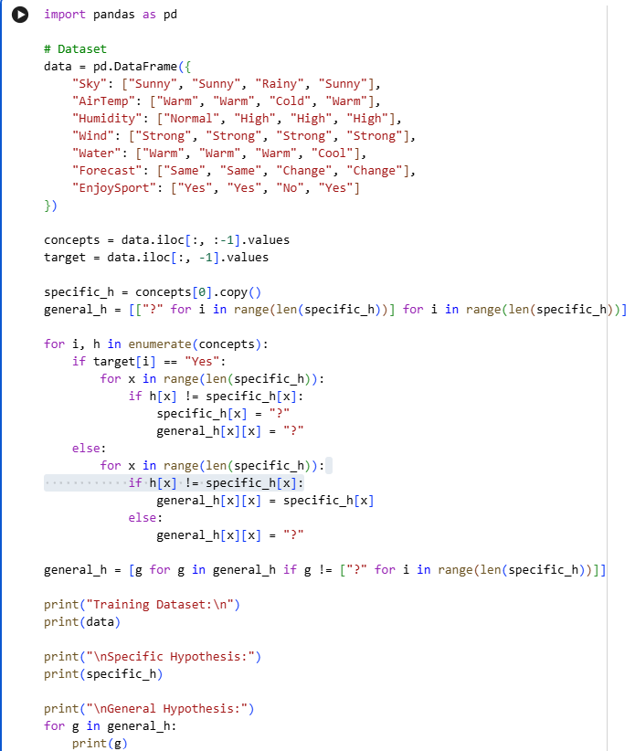
INPUT:

OUTPUT:
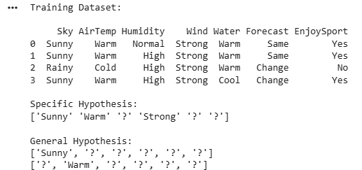

EXPERIMENT NO: 3
IMPLEMENTATION OF ID3 DECISION TREE ALGORITHM
Aim
To implement the ID3 Decision Tree algorithm in Python for building a decision tree model and to classify new data samples using the trained model.
Procedure
- Import the required Python libraries.
- Load the dataset from a CSV file.
- Preprocess the dataset by separating the input features and target labels.
- Calculate the entropy and information gain for each attribute.
- Select the attribute with the highest information gain as the root node.
- Recursively split the dataset to construct the decision tree.
- Train the ID3 Decision Tree model using the training dataset.
- Test the model with a new sample.
- Display the generated decision tree and the predicted class label.
- Evaluate the performance of the model using the test data.
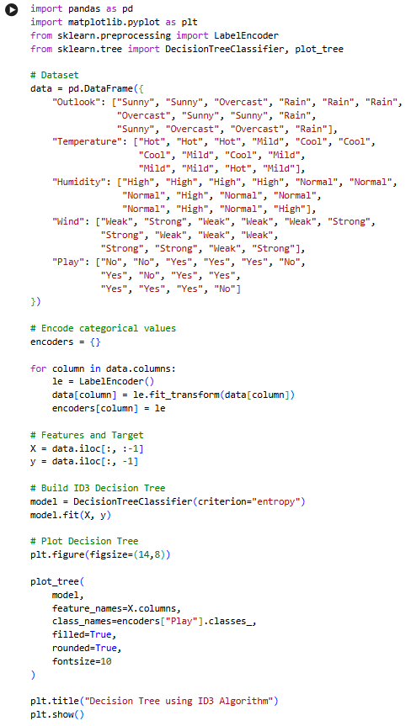
INPUT:

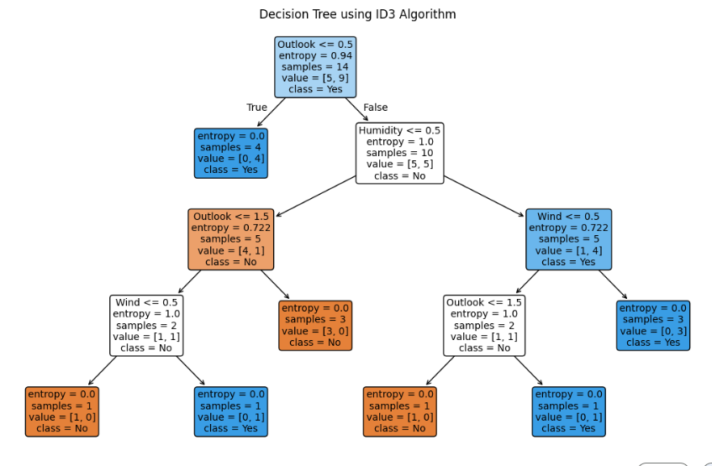
OUTPUT:

EXPERIMENT NO: 4
IMPLEMENTATION OF ARTIFICIAL NEURAL NETWORK USING BACKPROPAGATION ALGORITHM
Aim
To implement an Artificial Neural Network (ANN) using the Backpropagation algorithm in Python and test its performance using an appropriate dataset.
Procedure
- Import the required Python libraries.
- Load the dataset and preprocess the input features and target values.
- Split the dataset into training and testing sets.
- Initialize the Artificial Neural Network with input, hidden, and output layers.
- Assign random weights and biases to the network.
- Train the network using the Backpropagation algorithm by performing forward and backward propagation.
- Update the weights iteratively to minimize the error.
- Test the trained model using the testing dataset.
- Predict the output for the test samples.
- Display the predicted results and evaluate the performance of the neural network.
INPUT:
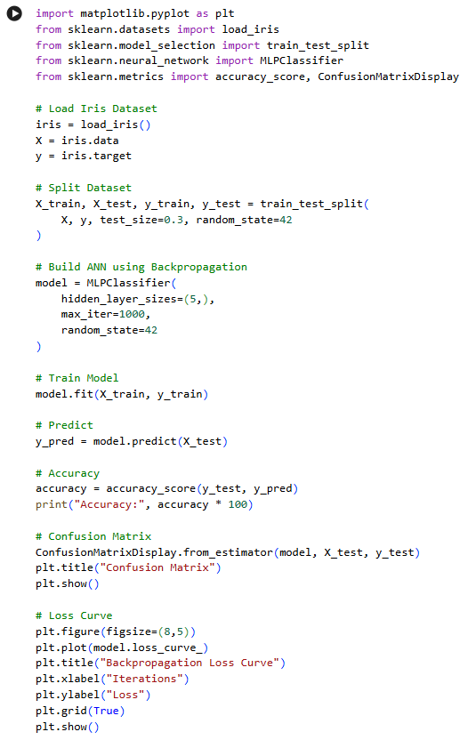

OUTPUT: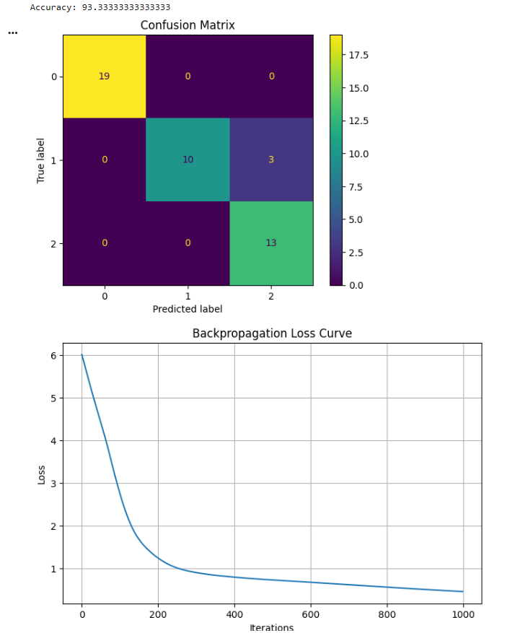

EXPERIMENT NO: 5
IMPLEMENTATION OF K-NEAREST NEIGHBOURS (K-NN) ALGORITHM
Aim
To implement the K-Nearest Neighbours (K-NN) algorithm in Python and classify the given data samples based on the nearest neighbours.
Procedure
- Import the required Python libraries.
- Load the dataset and preprocess the data.
- Split the dataset into training and testing sets.
- Select an appropriate value for K (number of nearest neighbours).
- Train the K-NN classifier using the training dataset.
- Calculate the distance between the test sample and all training samples.
- Identify the K nearest neighbours based on the calculated distances.
- Predict the class label using the majority voting method.
- Display the predicted results for the test dataset.
- Evaluate the performance of the K-NN model using suitable evaluation metrics such as accuracy.
INPUT
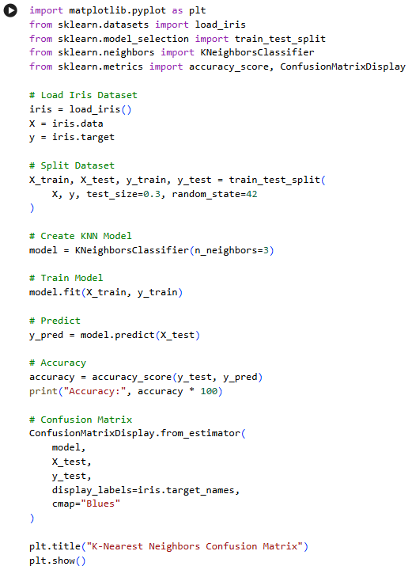

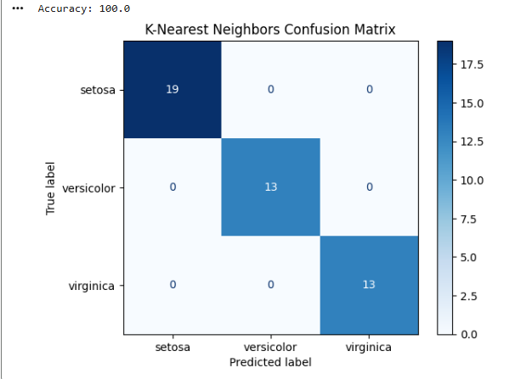
OUTPUT

EXPERIMENT NO: 6
IMPLEMENTATION OF NAÏVE BAYES ALGORITHM
Aim
To implement the Naïve Bayes algorithm in Python and evaluate its performance using a confusion matrix and accuracy score.
Procedure
- Import the required Python libraries.
- Load the dataset and preprocess the data.
- Split the dataset into training and testing sets.
- Train the Naïve Bayes classifier using the training dataset.
- Use the trained model to predict the class labels for the test dataset.
- Compare the predicted labels with the actual labels.
- Generate the confusion matrix to evaluate the classification results.
- Calculate the accuracy of the model.
- Display the confusion matrix and accuracy score.
- Interpret the results obtained from the Naïve Bayes classifier
INPUT
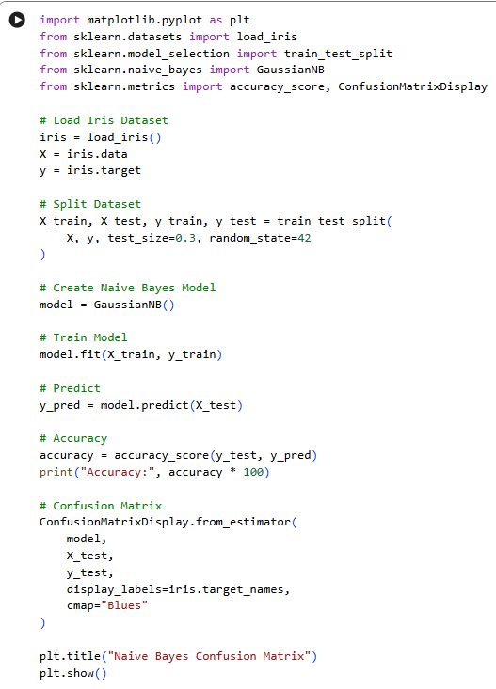

OUTPUT
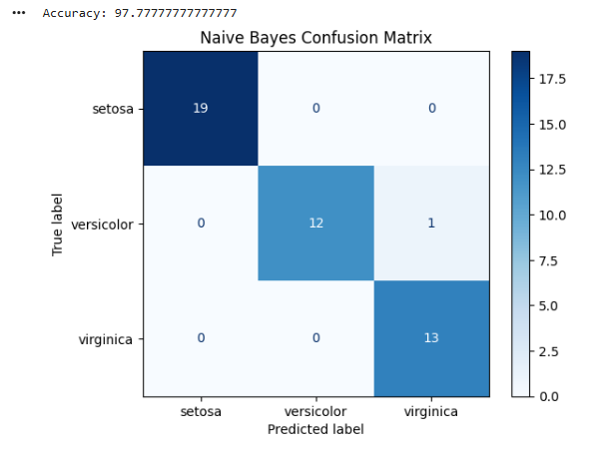

EXPERIMENT NO: 7
IMPLEMENTATION OF LOGISTIC REGRESSION ALGORITHM
Aim
To implement the Logistic Regression algorithm in Python for classifying data and predicting the target class using an appropriate dataset.
Procedure
- Import the required Python libraries.
- Load the dataset and preprocess the data.
- Split the dataset into training and testing sets.
- Create and train the Logistic Regression model using the training dataset.
- Predict the class labels for the testing dataset.
- Compare the predicted labels with the actual labels.
- Evaluate the model using suitable performance metrics such as accuracy.
- Display the predicted results.
- Analyze the performance of the Logistic Regression model.
- Interpret the classification results.
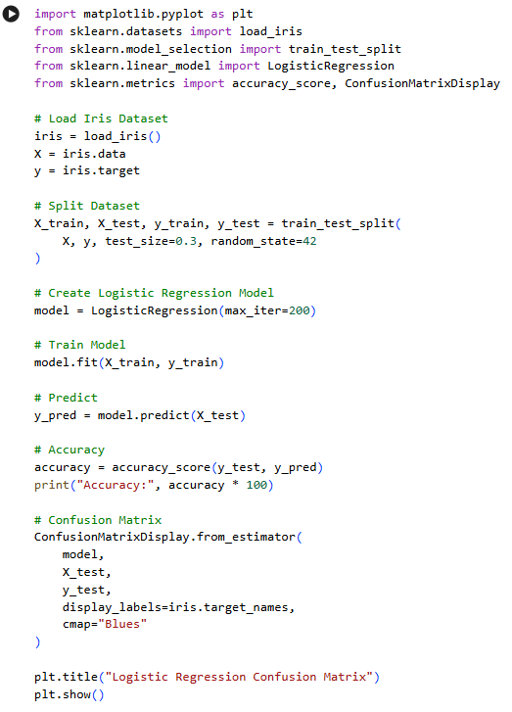
INPUT

OUTPUT
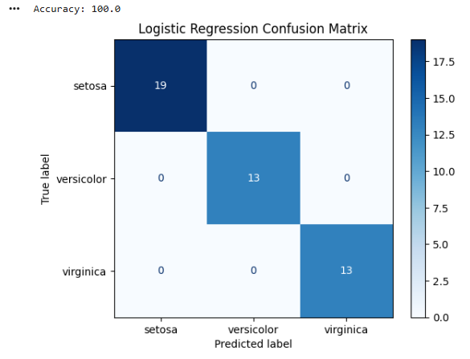

EXPERIMENT NO: 8
IMPLEMENTATION OF LINEAR REGRESSION ALGORITHM
Aim
To implement the Linear Regression algorithm in Python for predicting continuous values using an appropriate dataset.
Procedure
- Import the required Python libraries.
- Load the dataset and preprocess the data.
- Separate the input features and target variable.
- Split the dataset into training and testing sets.
- Create and train the Linear Regression model using the training data.
- Predict the target values for the testing dataset.
- Compare the predicted values with the actual values.
- Evaluate the performance of the model using suitable metrics such as Mean Squared Error (MSE) and R² score.
- Display the predicted results.
- Interpret the performance of the Linear Regression model.
INPUT
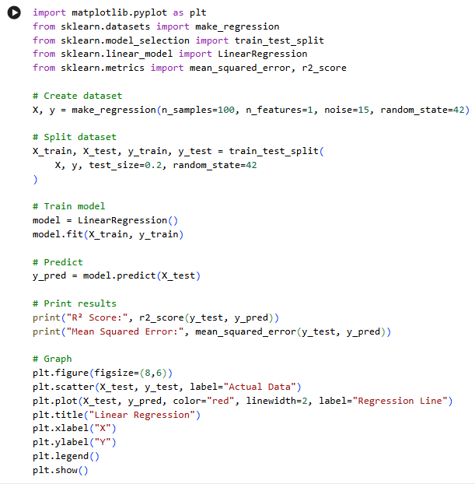

OUTPUT
